**Monitoring System in Greenhouse**

**Hardware:-**

1. Arduino UNO R3
2. VIPER Switching Power Supply 9V 2A/ USB type A - USB B Link Cable
3. NodeMCU
4. Data Logging Shield for Arduino
5. DHT11 sensor
6. DS18B20 sensor
7. Analog pH Meter Kit (3 in 1 sensor)
8. NEO-6M GPS Module
9. Analog UV Light Sensor Breakout - GUVA-S12SD
10. SD card
11. Breadboard (Optional)
12. Jumper Wires (Optional)

**Arduino Software (IDE):-** Download the Arduino IDE using the link <https://www.arduino.cc/en/software#experimental-software>

**Installation:**

1. **For Windows:-** To install the IDE on a Windows computer, run the downloaded file from the link.

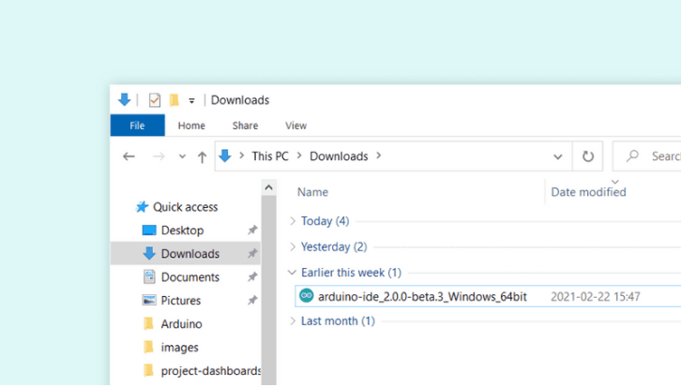

Follow the instructions given below to install,

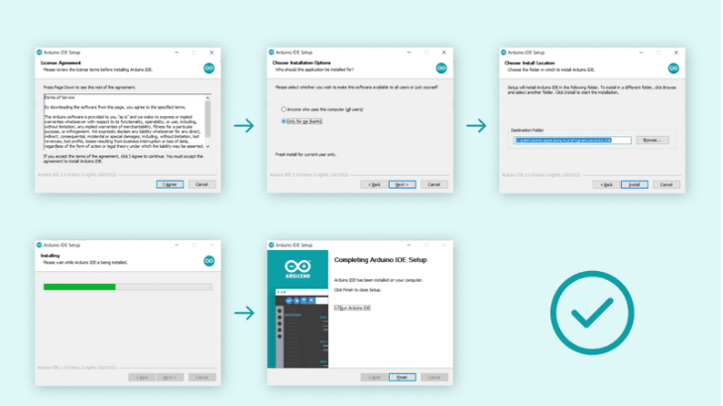

1. **Mac OS X:-** To install the IDE on a Mac OS X computer, copy the downloaded file into your application folder.

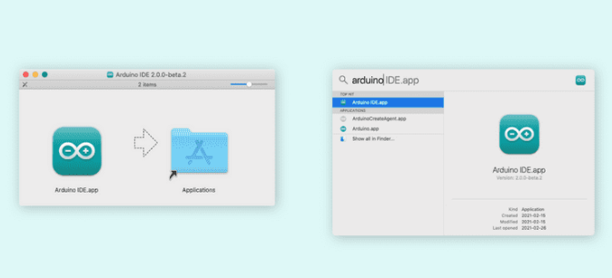

1. **Linux:-** To install the IDE on Linux, extract the downloaded file to the folder.

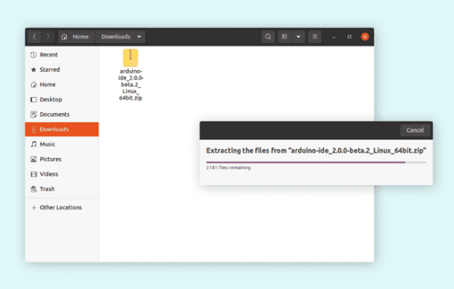

Go to the folder where you extracted the file, and look for the **arduino-ide** file that will launch the IDE. You can also run the file directly in the terminal, navigate to the folder, right-click on it and select run in terminal.

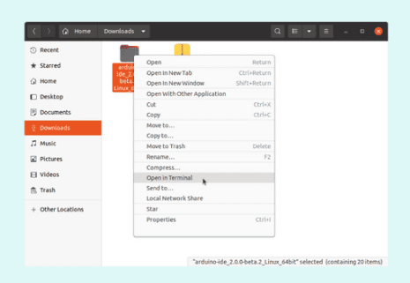

If you downloaded and expanded the Zip package or, for some reason, the board wasn't properly recognized, please follow the procedure below.

* Click on the Start Menu, and open up the Control Panel.
* While in the Control Panel, navigate to System and Security. Next, click on System. Once the System window is up, open the Device Manager.
* Look under Ports (COM & LPT). You should see an open port named "Arduino UNO (COMxx)". If there is no COM & LPT section, look under "Other Devices" for "Unknown Device".
* Right click on the "Arduino UNO (COmxx)" port and choose the "Update Driver Software" option.
* Next, choose the "Browse my computer for Driver software" option.
* Finally, navigate to and select the driver file named "**arduino.inf**", located in the "Drivers" folder of the Arduino Software download (not the "FTDI USB Drivers" sub-directory). If you are using an old version of the IDE (1.0.3 or older), choose the Uno driver file named "Arduino UNO.inf"
* Windows will finish up the driver installation from there.

Open the sketch and follow the instructions given below,

* To create a new file or open an existing file click the **File** icon on the top left corner,

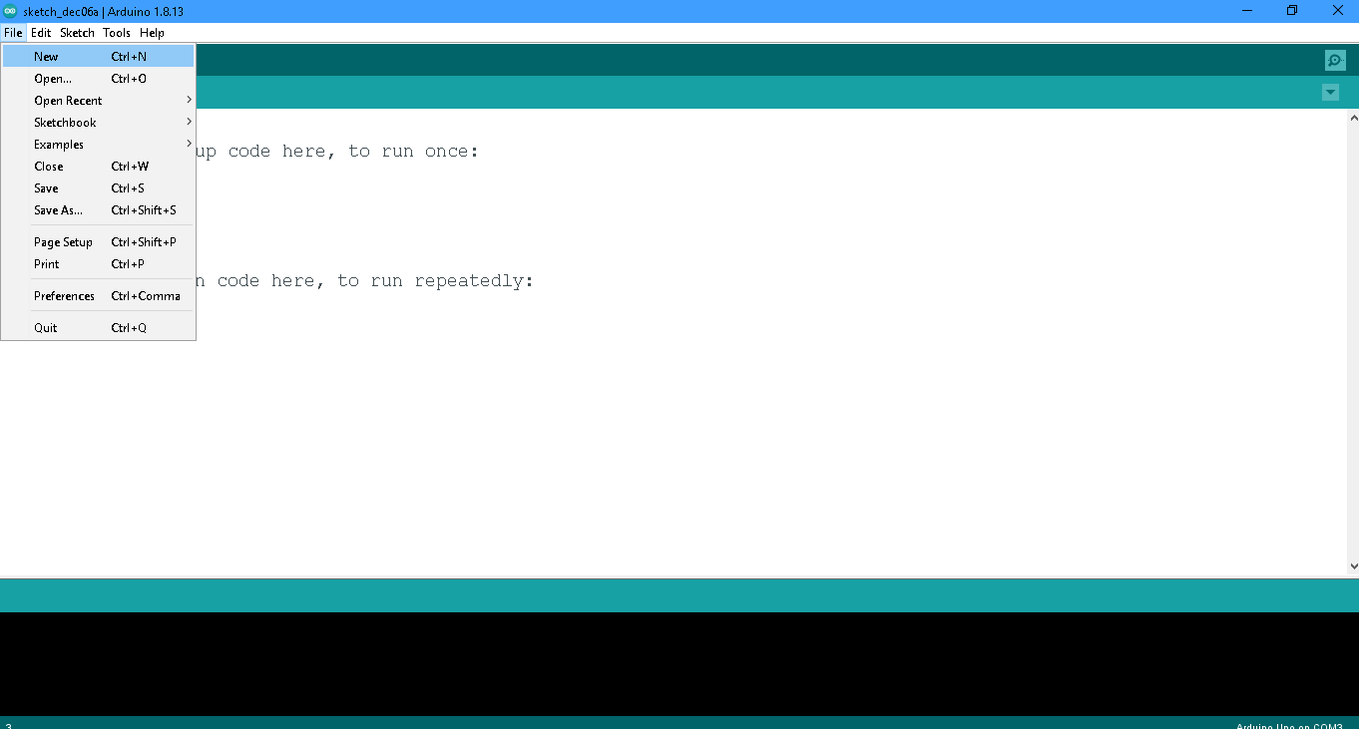

* After opening the file you need to select the board by clicking on **Tools,**

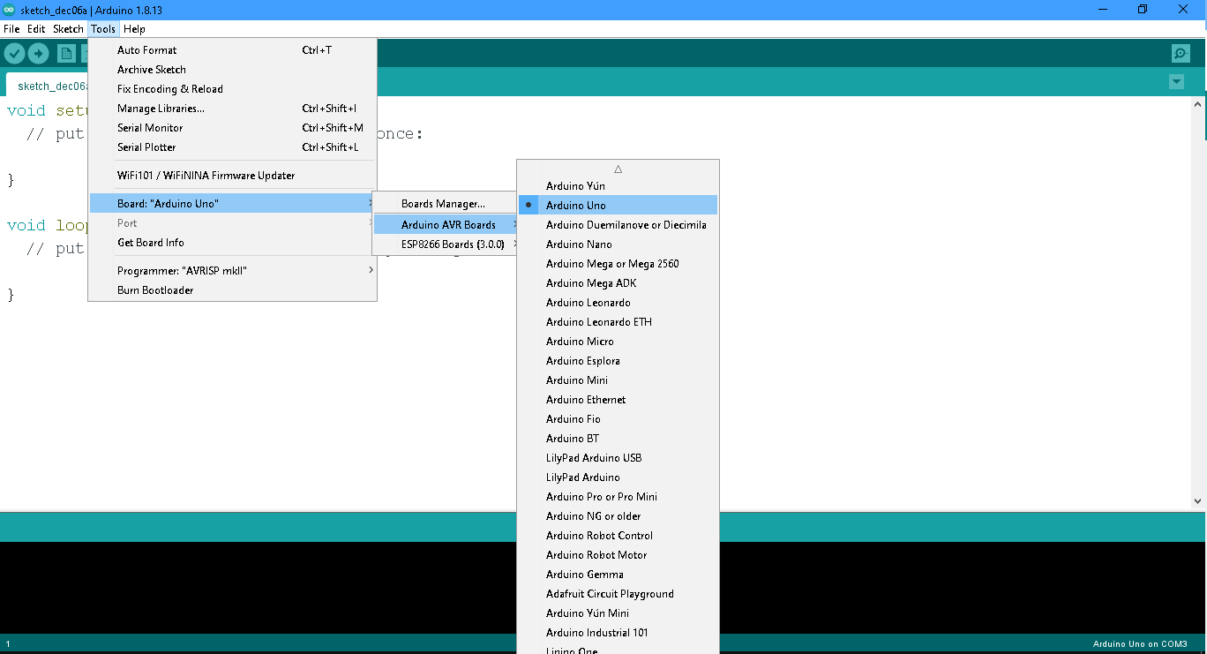

For NodeMCU follow the instruction in the below pic,

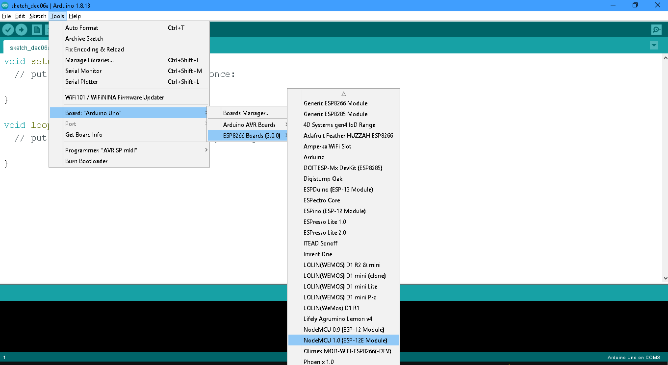

* Then select the port by clicking the **Port** in **Tools** after connecting the Arduino UNO and NodeMCU to the computer using USB (ports for both devices are different).

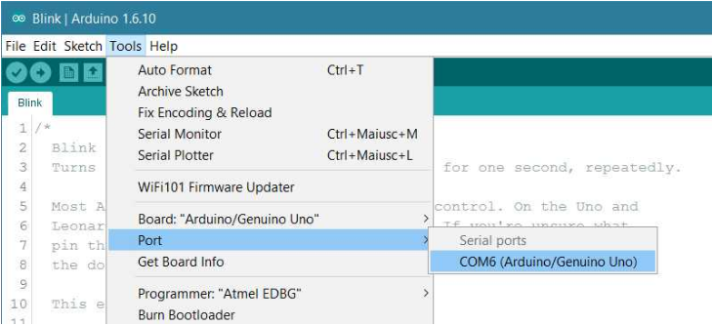

* To verify/compile click the **✓** sign on the top left corner and to upload the sketch on board and click the ⇨ sign on the left top corner (only clicking the ⇨ sign ).

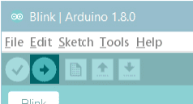

* To see the serial monitor click on the top left corner as shown in the pic below.

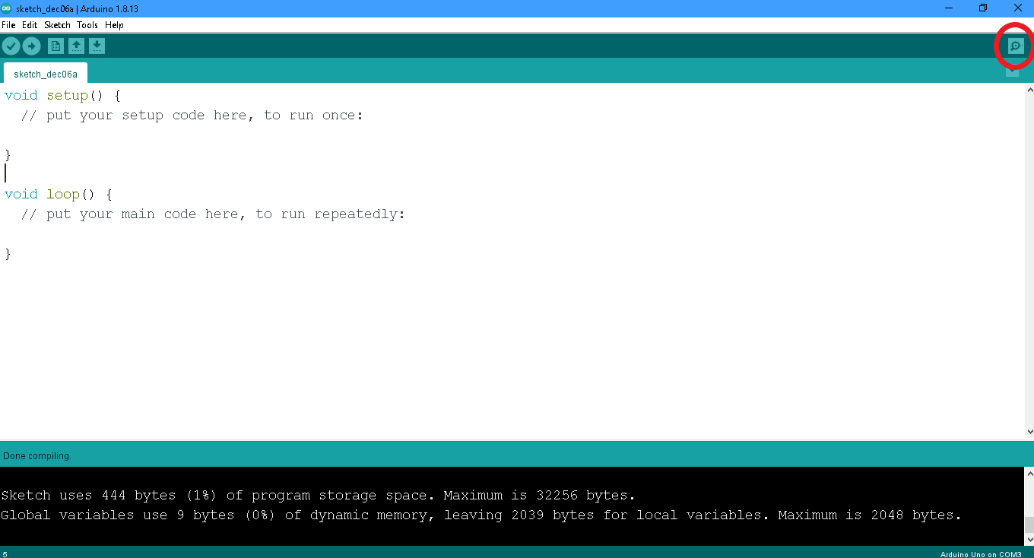

**Preparing for NodeMCU:-** Go to the ***File ➔ Preferences,*** there is section called “Additional Boards manager URLs:” at the bottom. Paste this URL in the field next to this,

<http://arduino.esp8266.com/stable/package_esp8266com_index.json>

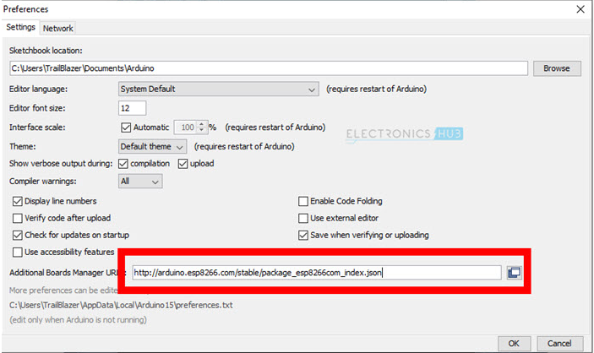

Make sure your system connected to the internet. Now go to the ***Tools -> Board -> Boards Manager*** option, using the search field at the top search for esp8266. You will get the result as ‘esp8266 by ESP8266 Community’. Select this option and download all tools.

***Note:-*** *You can download other useful libraries by following the this step.*

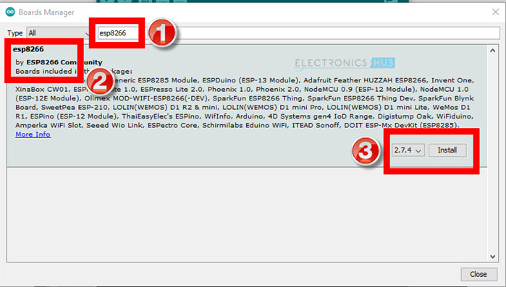

After installing the ESP8266 boards, you can start writing code for your new NodeMCU board. First, connect the micro-USB cable to the NodeMCU and plug-in the other side of the cable to the computer.

Now, once again go to ***Tools -> Board -> ESP8266 Boards*** in the Arduino IDE and select **“*NodeMCU 1.0 ESP-12E Module*”**.

